Math 1010 ~ Quadratic Activity Lab

This activity we will learn how to graph the quadratic function which is called the parabola, $f\left(x\right)=ax^{2}+bx+c$.

The most basic quadratic function is $f\left(x\right)=ax^{2}$

Let’s look at the function when a = 1

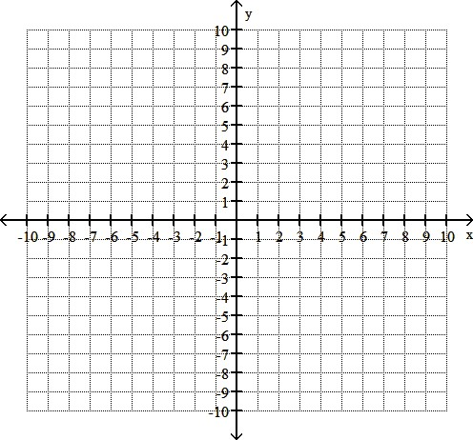
Fill out the table and then plot the points and graph the following function:
x | $$f\left(x\right)=x^{2}$$ | (x, $f\left(x\right)$)

-3

-2

-1

0

1

2

3

Make sure your graph has a nice “rounded” curve at the bottom.

Go to the following link:

http://www.mathopenref.com/quadraticexplorer.html

Click “zero” under all three sliders.

Moving the “a” slider:
- As you move “a” up and down:
  - Describe what happens to the quadratic function when “a” is a positive number.

  - Describe what happens to the quadratic function as you allow “a” to get very close to a = 0, but leave “a” positive?

  - Describe what happens to the quadratic function as you allow “a” to get larger in the positive direction.

  - Describe what happens to the quadratic function when “a” is a negative number.

]
  - Describe what happens to the quadratic function as you allow “a” to get very close to a = 0 but leave “a” negative?

  - Describe what happens to the quadratic function as you allow “a” to get larger in the negative direction.

- Generalize what happens as you move “a”.

Let’s look at the function when “a” is a different number.

$$f\left(x\right)=2x^{2}$$

Fill out the table and then plot the points and graph the following function:
x | $$f\left(x\right)=2x^{2}$$ | (x, $f\left(x\right)$)

-3

-2

-1

0

1

2

3

$$f\left(x\right)=\frac{1}{2}x^{2}$$

Fill out the table and then plot the points and graph the following function:
x | $$f\left(x\right)=\frac{1}{2}x^{2}$$ | (x, $f\left(x\right)$)

-3

-2

-1

0

1

2

3

Go back to the link and put the “a” slider to a = 1 and the “c” slider to c = 0.

Moving the “b”slider:
- As you leave both “a” and “c” alone, move “b” up and down:
  - Describe what happens to the quadratic function when “b” is a positive number.

  - Describe what happens to the quadratic function when “b” is a negative number.

  - Describe what happens to the quadratic function as you allow “b” to get larger in the positive direction.

  - Describe what happens to the quadratic function as you allow “b” to get larger in the negative direction.

  - Now let a = -1 and try # a-d again.

- Generalize what happens as you move “b”.

Put the “a” slider to a = 1 and the “b” slider to b = 0.

Moving the “c” slider:
- As you leave both “a” and “b” alone, move “c” up and down:
  - Describe what happens to the quadratic function when “c” is a positive number.

  - Describe what happens to the quadratic function when “c” is a negative number.

  - Describe what happens to the quadratic function as you allow “c” to get larger in the positive direction.

  - Describe what happens to the quadratic function as you allow “c” to get larger in the negative direction.

  - Now let a = -1 and try a-d again.

- Generalize what happens as you move “c”.

Play for a moment with all three sliders.

Let’s now look at the quadratic function in a different form:

$$f\left(x\right)=a{\left(x-h\right)}^{2}+k$$

We call the point (h, k) the vertex of the parabola.

Let’s once again go to a link and explore:

http://www.mathopenref.com/quadvertexexplorer.html

Click “zero” under all three sliders.

Moving the “a” slider:

- Generalize what happens as you move “a”.

- Do you think the “a” in this form behaves like the “a” in the standard form? Why or why not?

Put the “a” slider to a = 1 and the “k” slider to k = 0.

Moving the “h” slider:
- As you leave both “a” and “k” alone, move “h” up and down:
  - Describe what happens to the quadratic function when “h” is a positive number.

  - Describe what happens to the quadratic function when “h” is a negative number.

  - Now let a = -1 and try # a and # b again.

- Generalize what happens as you move “h”.

Put the “a” slider to a = 1 and the “h” slider to h = 0.

Moving the “k” slider:
- As you leave both “a” and “h” alone, move “k” up and down:

  - Describe what happens to the quadratic function when “k” is a positive number.
  - Describe what happens to the quadratic function when “k” is a negative number.

  - Now let a = -1 and try # a and # b again.

- Generalize what happens as you move “k”.

- Generalize about the formula $f\left(x\right)=a{\left(x-h\right)}^{2}+k$

Play for a moment with all three sliders.

Let’s graph when “h” and “k” are different numbers.

If you need help, go back to the link. And put in the appropriate numbers.

$$f\left(x\right)=1{\left(x-1\right)}^{2}+2$$
x | $$f\left(x\right)=1{\left(x-1\right)}^{2}+2$$ | (x, $f\left(x\right)$)

-3

-2

-1

0

1

2

3

Fill out the table and then plot the points and graph the following function:

$$f\left(x\right)=-1{\left(x-1\right)}^{2}+2$$
x | $$f\left(x\right)=-1{\left(x-1\right)}^{2}+2$$ | (x, $f\left(x\right)$)

-3

-2

-1

0

1

2

3

Fill out the table and then plot the points and graph the following function:

$$f\left(x\right)=1{\left(x+1\right)}^{2}-3$$
x | $$f\left(x\right)=1{\left(x+1\right)}^{2}-3$$ | (x, $f\left(x\right)$)

-3

-2

-1

0

1

2

3

Fill out the table and then plot the points and graph the following function:

$$f\left(x\right)=-1{\left(x+1\right)}^{2}-3$$
x | $$f\left(x\right)=-1{\left(x+1\right)}^{2}-3$$ | (x, $f\left(x\right)$)

-3

-2

-1

0

1

2

3

Fill out the table and then plot the points and graph the following function:

$$f\left(x\right)=-2{\left(x+3\right)}^{2}-5$$
x | $$f\left(x\right)=-2{\left(x+3\right)}^{2}-5$$ | (x, $f\left(x\right)$)

-3

-2

-1

0

1

2

3

Fill out the table and then plot the points and graph the following function:

